

East West University

PROJECT REPORT

Project Title: Project Title: Hotel Booking System (Hotel EWU)

Course Name : CSE302 – Database Systems
Section : 08
Semester : SUMMER-2026
Group : 04
Project URL: https://oracleapex.com/ords/r/365/hotel-ewu/welcome
Workspace : 365
Username : 2024-3-60-365@std.ewubd.edu
Password : #JetuArghoTawsif123
Submitted to
Khairum Islam
Lecturer
Department of CSE

Submitted by:
Student ID | Student Name | Contribution Percentage
Nayem Islam Jetu | 2024-1-60-222 | 30
Tawsif Hossain Khan | 2024-3-60-365 | 40
Sourov Kumar Argho | 2024-3-60-572 | 30

1.E-R Model of the Project:
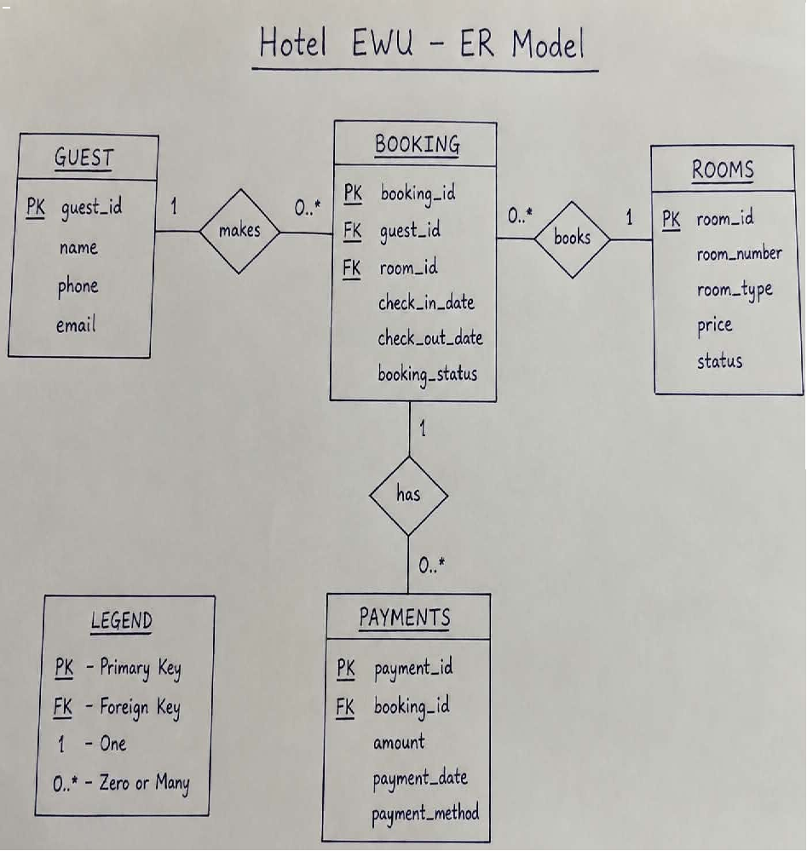

Figure : Entity-Relationship Diagram of the Hotel Booking System

The system is built around four core entities: Rooms, Guests, Bookings, and Payments.
• A Room can appear in many Bookings over time, but never in two overlapping bookings at once.
• A Guest can make many Bookings (one-to-many).
• A Booking can have one or more associated Payments (e.g., a deposit followed by a balance payment).
Assumptions: A booking always belongs to exactly one guest and one room. A guest's identity is uniquely determined by their phone number, which is used to automatically find or create a guest record when a booking is made through the public booking form.

2.Relational Data Model of the Project:

The relational schema (with primary keys, foreign keys, and constraints) implemented in Oracle SQL is shown below.
ROOMS (room_id PK, room_number, room_type, price, status)
GUESTS (guest_id PK, name, phone)
BOOKINGS (booking_id PK, guest_id FK → GUESTS, room_id FK → ROOMS, check_in_date, check_out_date, booking_status)
PAYMENTS (payment_id PK, booking_id FK → BOOKINGS, amount, payment_date, payment_method)
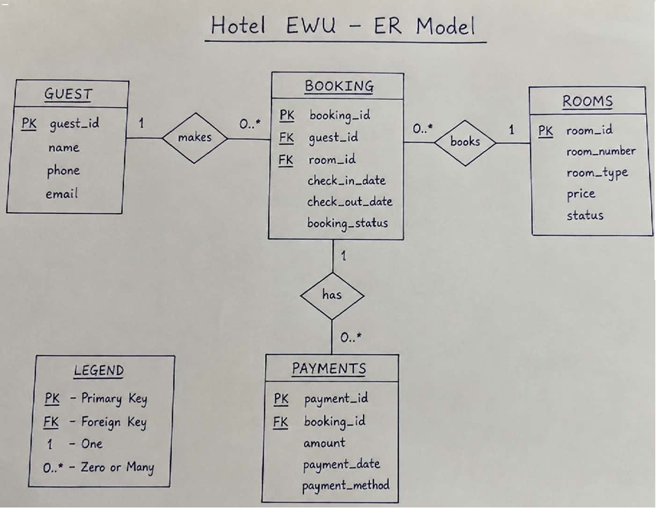

Figure : Relational Data Model
Assumptions: check_out_date is always strictly greater than check_in_date. Room status is one of Available / Occupied / Maintenance. Payment method is one of Cash / Card / Online.

3.Implementation Checklist:

Description | Remarks
Project ID | 52118
Workspace Name | 365
Workspace Email | 2024-3-60-365@std.ewubd.edu
Workspace Password | #JetuArghoTawsif123
Authentication Type | Application Express (built-in)
Username and Password to Login | Admin: 2024-3-60-365@std.ewubd.edu pass: #JetuArghoTawsif123
If multiple users | The application uses a single Administrator account (workspace owner) for backend management. All hotel guests/customers use the system anonymously through a public, login-free booking page — no customer account is required.
Uploaded and Displayed Images in Reports | No
Implemented Page-wise Authorization | Yes — see Section 9
Number of Reports with Forms | 4 (Rooms, Guests, Bookings, Payments)
Number of Master-detail Forms | 1 (Guests → Bookings)
Number of Reports based on Queries, Aggregate Queries | 2 (Stay-duration report per booking; average-stay-duration chart per room type)
Number of Parameterized Reports | 1 (room availability check by check-in/check-out date, used to filter the room list on the booking form)
Number of Graphs/Charts | 4 (Monthly Revenue, Most-Booked Room Types, Available Rooms by Type, Average Stay Duration by Room Type)
Included any trigger/other feature not taught in class | Yes — see Section 3.1 below
Most unique feature | See Section 3.2 below

4.Trigger and Extra Features:

A BEFORE INSERT OR UPDATE trigger (trg_prevent_double_booking) was implemented on the BOOKINGS table. Before any booking is saved, it checks whether the selected room already has a non-cancelled booking whose date range overlaps the new one; if so, it raises a custom application error (ORA-20001) and blocks the transaction. This was live-tested by attempting to double-book Room 201 for an overlapping date range, which was correctly rejected.
In addition, a PL/SQL page process on the public booking form automatically finds an existing guest by phone number or creates a new guest record on the fly — so a first-time customer never has to be manually added by staff before they can book.

5.Most Unique Feature:

The feature we are most proud of is the fully public, login-free "Book A Room" page. Unlike the rest of the application (which requires an Administrator login), this page lets any customer — with no account — check available rooms (filtered live through the vw_available_rooms VIEW), submit their name/phone/dates/payment, and receive a confirmation message, while a database trigger silently protects against double-booking in the background. The application's Welcome landing page separates these two audiences (Customer vs. Staff/Admin). with a single click, and the navigation menu automatically hides all administrative pages from anyone who is not logged in.

6.Reports with Forms:

Report Page Number and Name | Form Page Number and Name | Table
Page 2: Rooms | Page 3: Room | ROOMS
Page 4: Guests | Page 5: Guest | GUESTS
Page 6: Bookings | Page 7: Booking | BOOKINGS
Page 8: Payments | Page 9: Payment | PAYMENTS

Screenshots of each report/form pair follow, referencing the table each page is built on.
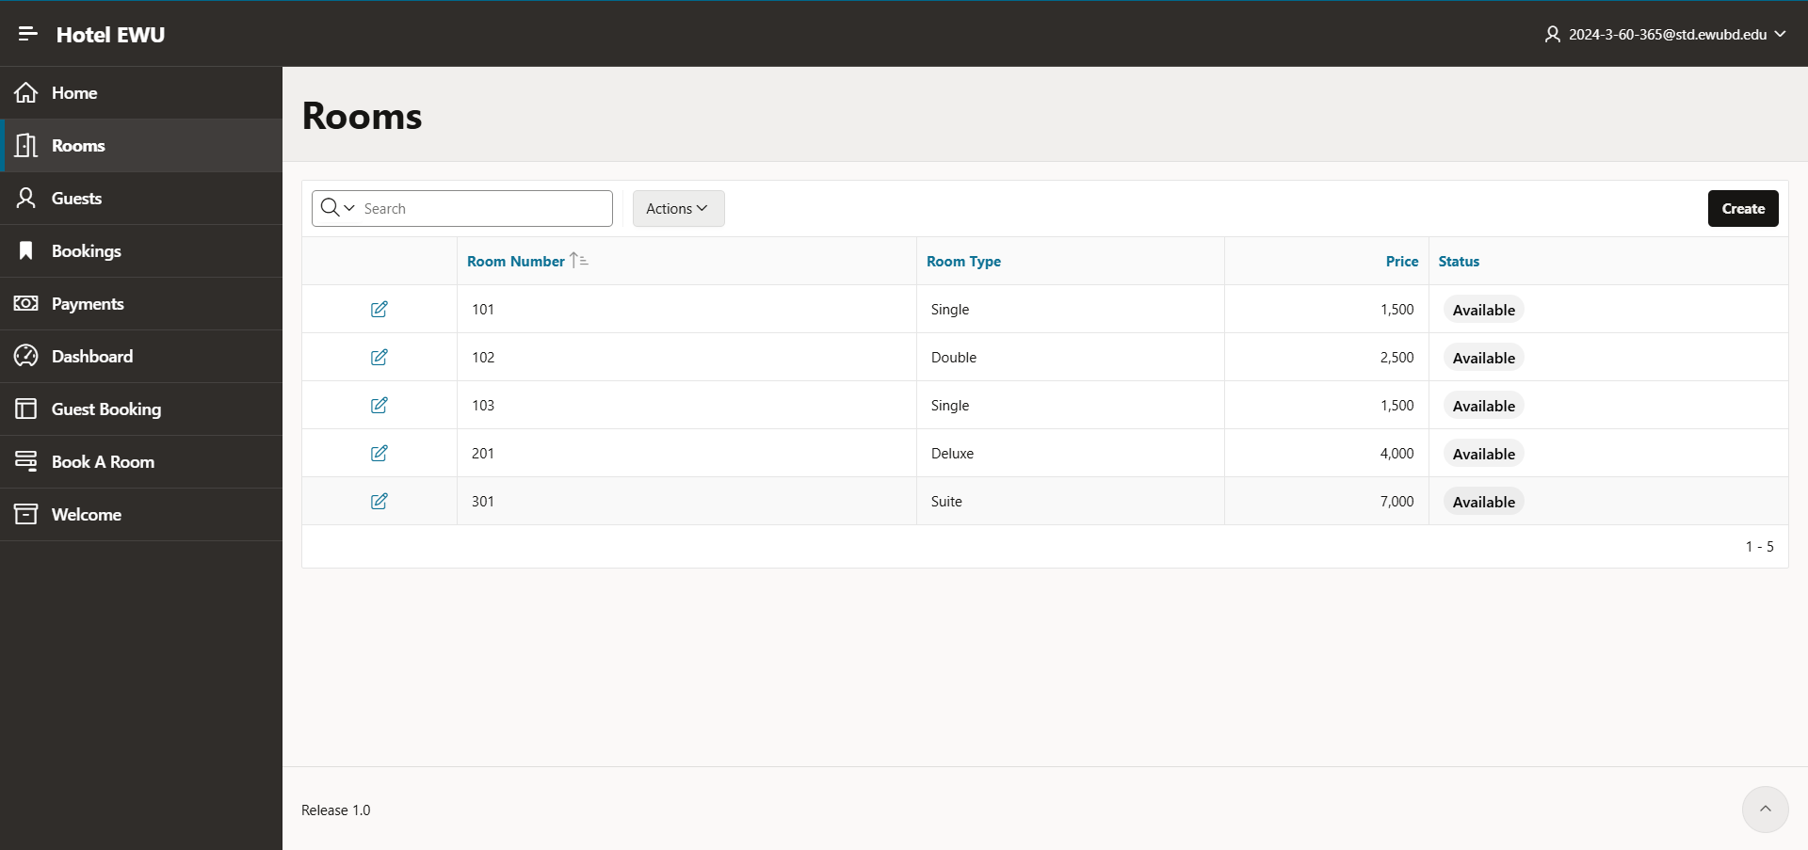

Figure : Rooms Interactive Report — table ROOMS

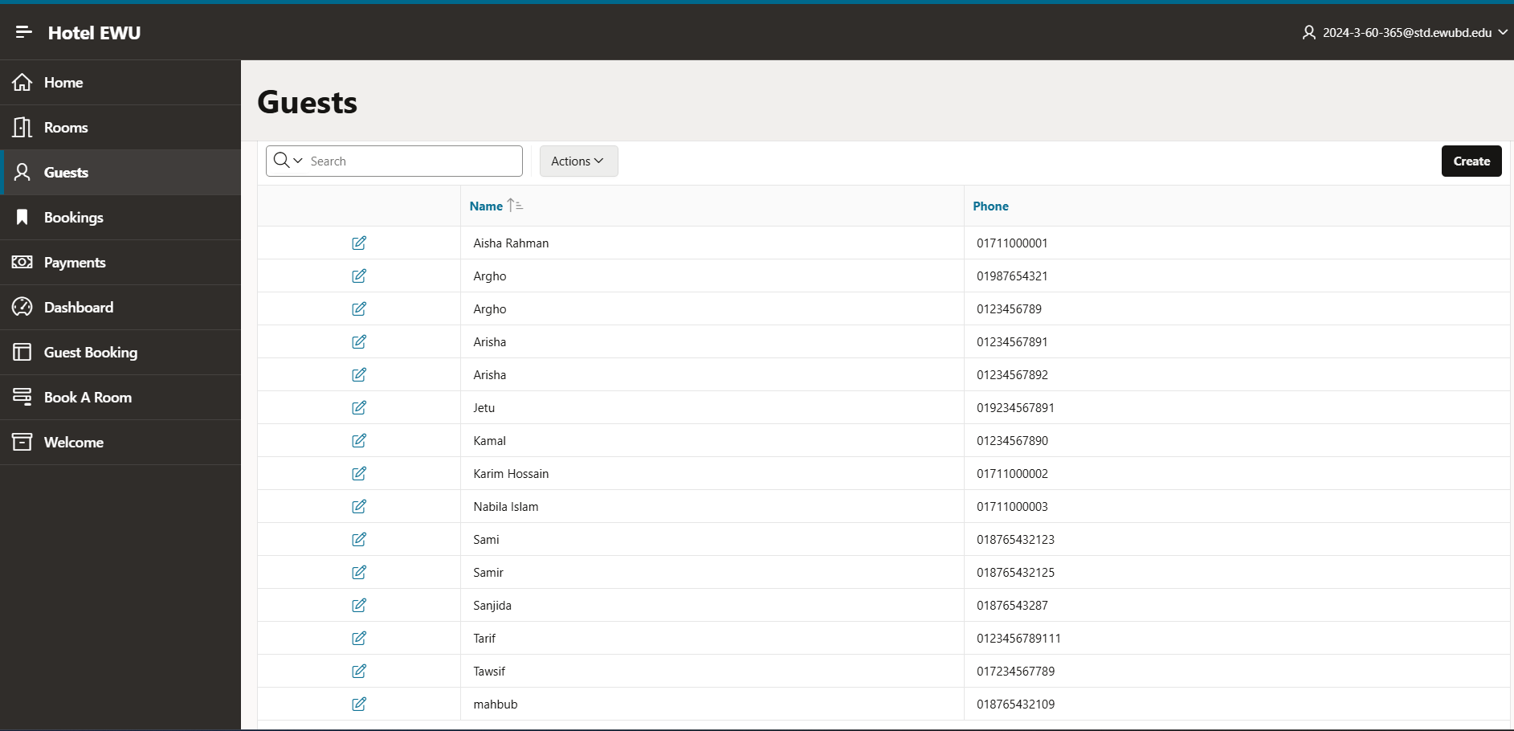

Figure : Guests Interactive Report — table GUESTS

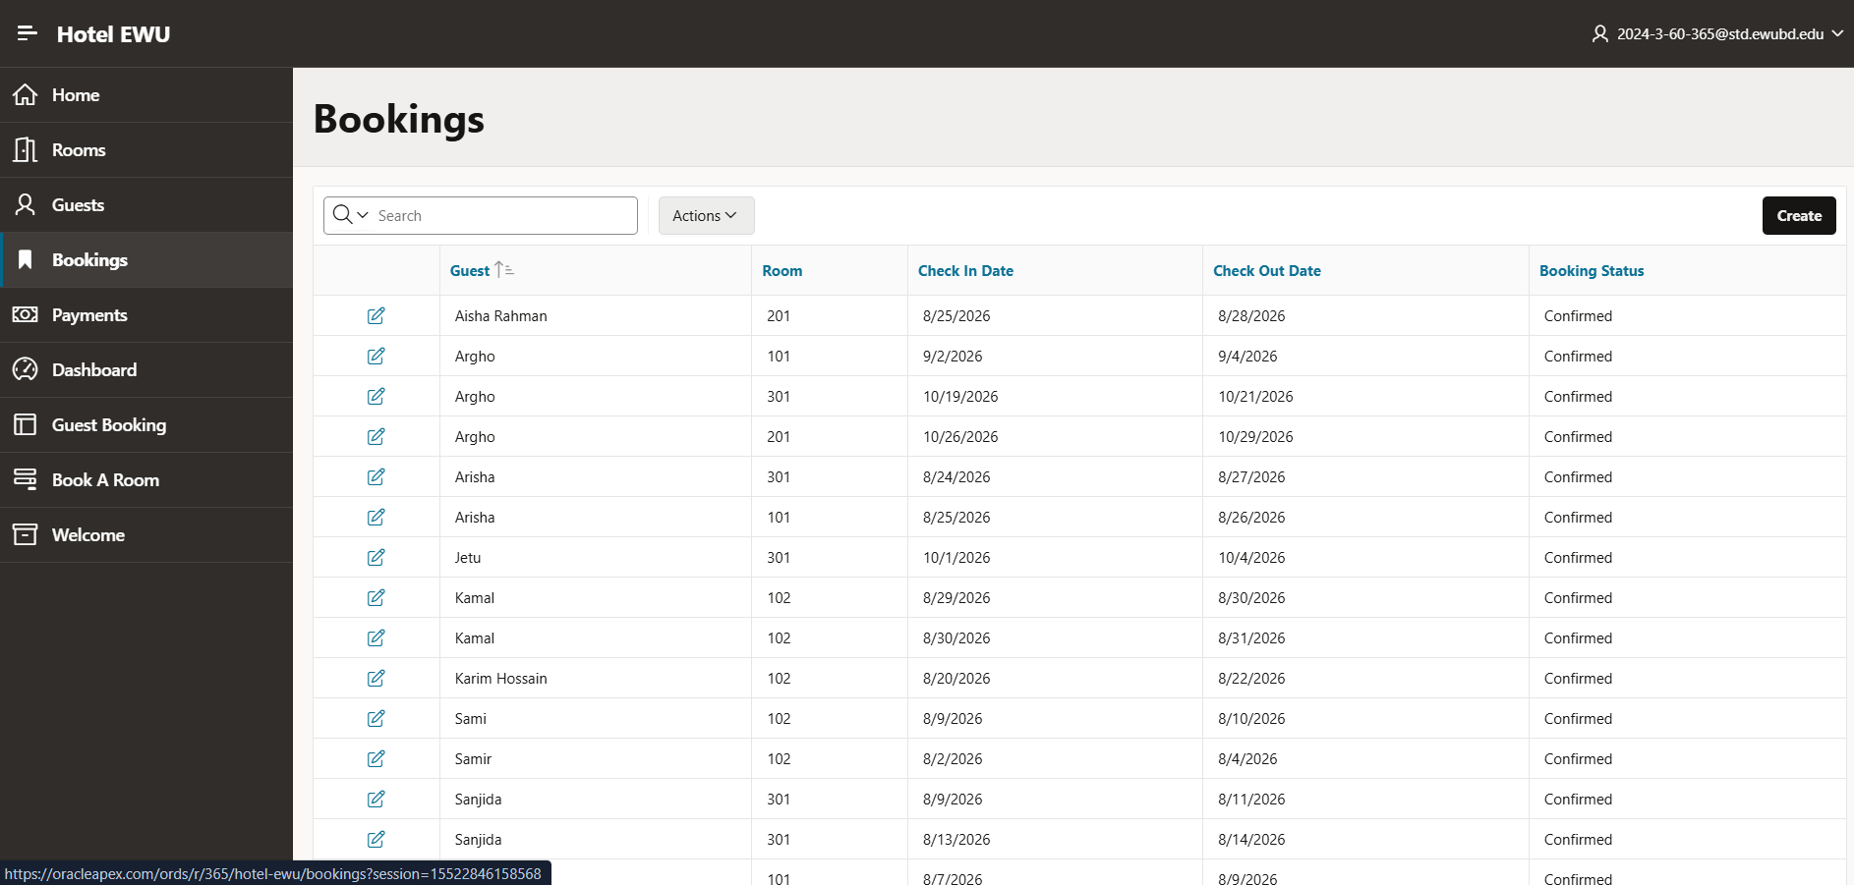
Figure : Bookings Interactive Report (left) and Booking Form (right) — table BOOKINGS

7.Master-Detail Form:

Page Number and Name | Master Table (Parent) | Detail Table (Child)
Page 13: Guest Booking | GUESTS | BOOKINGS

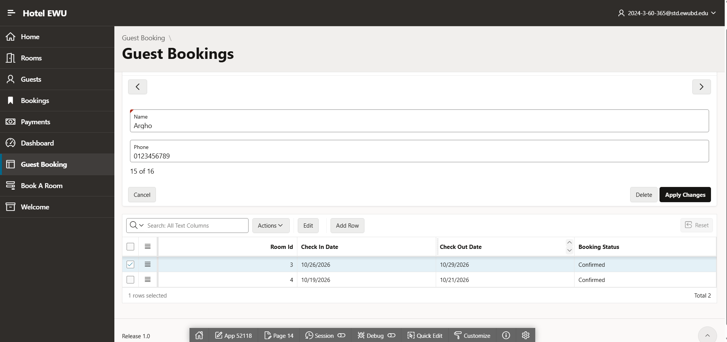
Figure: Guest Booking master-detail page — selecting a guest (master, GUESTS) shows all of their bookings (detail, BOOKINGS)

8.Reports based on Multi-Table and Aggregate Queries

Page Number and Name | Query Type | Report description
Page 6: Bookings — "Stay Duration Report" region | Multi-table + row-level expression | Joins BOOKINGS, GUESTS and ROOMS to show, for every booking, the guest name, room, check-in/out dates and the computed number of nights stayed (check_out_date − check_in_date).
Page 10: Dashboard — "Average Stay Duration by Room Type" chart | Aggregate (GROUP BY + AVG) | Groups all bookings by room type and shows the average number of nights guests stay in each room type, helping management understand booking patterns per category.

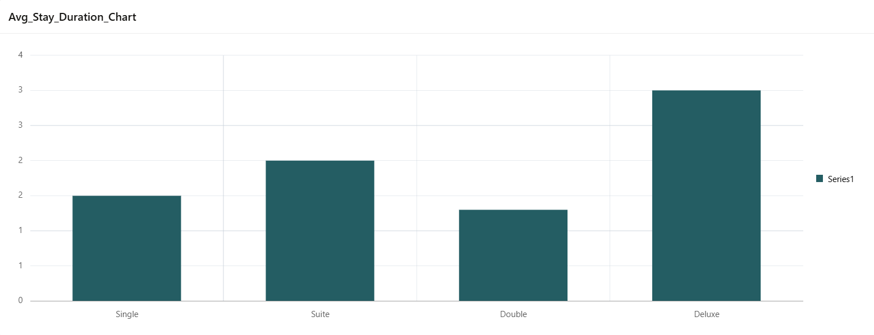
Figure :Average Stay Duration by Room Type

9.Parameterized Reports :

Page Number and Name | Given Input | Report description
Page 15: Book A Room — Room selection list | Check-in date, Check-out date | The room drop-down on the public booking form is filtered live by the guest's chosen check-in/check-out dates (via the vw_available_rooms view logic), so only rooms that are actually free for those dates are offered.

10.Charts and Other Pages:

Page Number and Name | Chart description
Page 10: Dashboard — Chart 1 | Bar chart showing total revenue collected per month, computed from the PAYMENTS table.
Page 10: Dashboard — Chart 2 | Pie chart showing the most frequently booked room types across all bookings.
Page 10: Dashboard — Chart 3 | Bar chart showing the number of rooms currently available, broken down by room type (live, using vw_available_rooms).
Page 10: Dashboard — Chart 4 | Bar chart showing the average stay duration (in nights) per room type, an aggregate query over BOOKINGS and ROOMS.

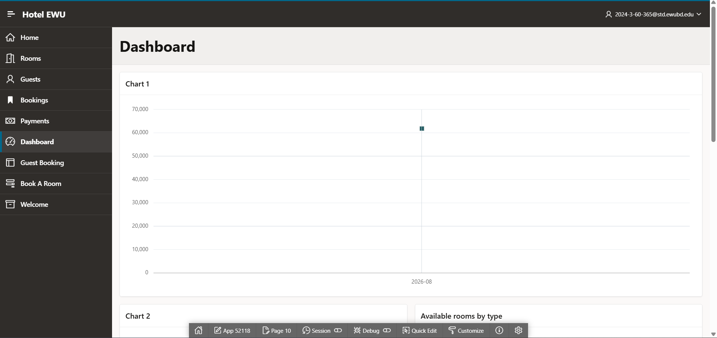
Figure : Monthly Revenue chart
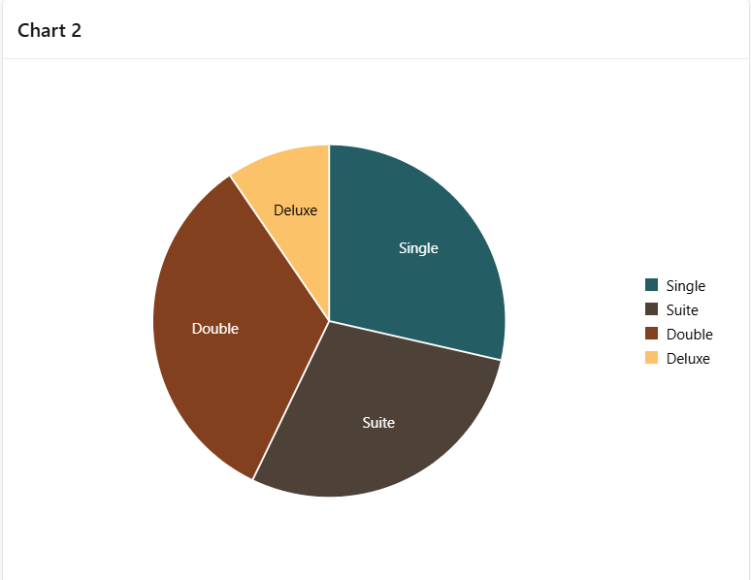
Figure : Most Booked Room Types chart
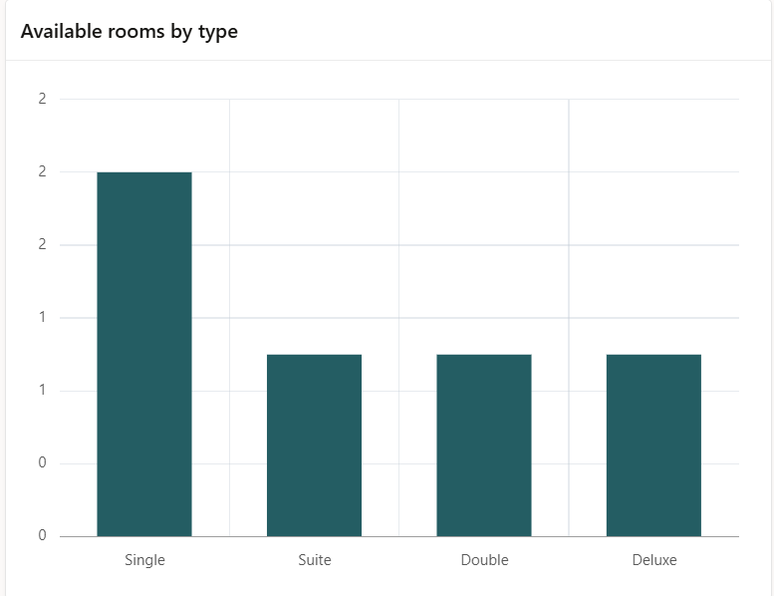
Figure : Available Rooms by Type chart

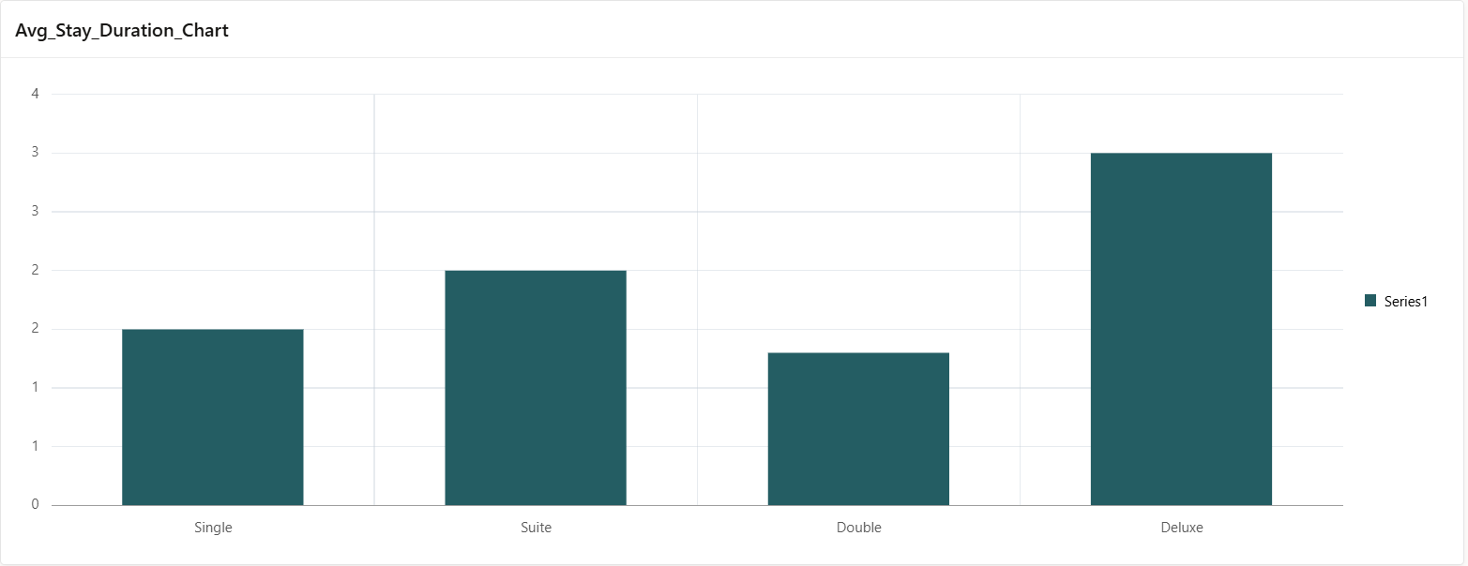
Figure :Average Stay Duration by Room Type

11.Authorization :

Page-wise Authorization Information

Page number and name | Authorization Level
P1: Home | Administrator (Must Not Be Public User)
P2/P3: Rooms / Room | Administrator
P4/P5: Guests / Guest | Administrator
P6/P7: Bookings / Booking | Administrator
P8/P9: Payments / Payment | Administrator
P10: Dashboard | Administrator
P13: Guest Booking (Master-Detail) | Administrator
P11: Welcome | Public (anyone, no login required)
P15: Book A Room | Public (anyone, no login required)

Authorization was implemented by attaching an authorization scheme ("Must Not Be Public User", a built-in APEX scheme) to every administrative navigation-menu entry and page. As a result, a logged-out visitor only ever sees Home, Book A Room and Welcome in the navigation bar — every other link redirects straight to the login page — while a logged-in Administrator sees and can use the full application.
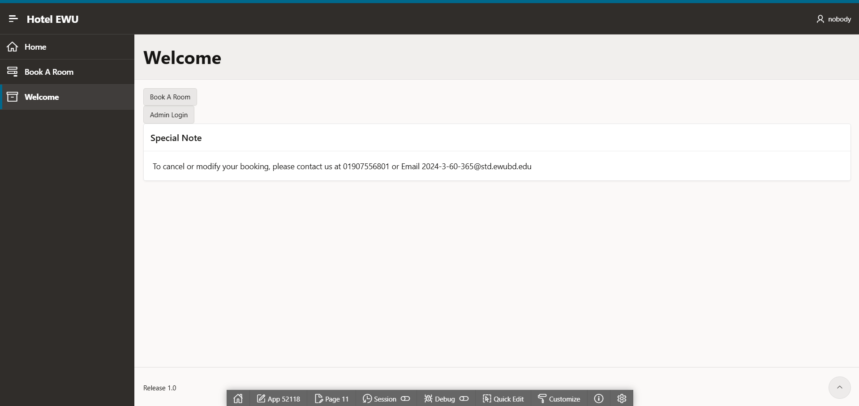
Figure: Welcome page as seen by a logged-out (public) visitor — only Home, Book A Room and Welcome are visible
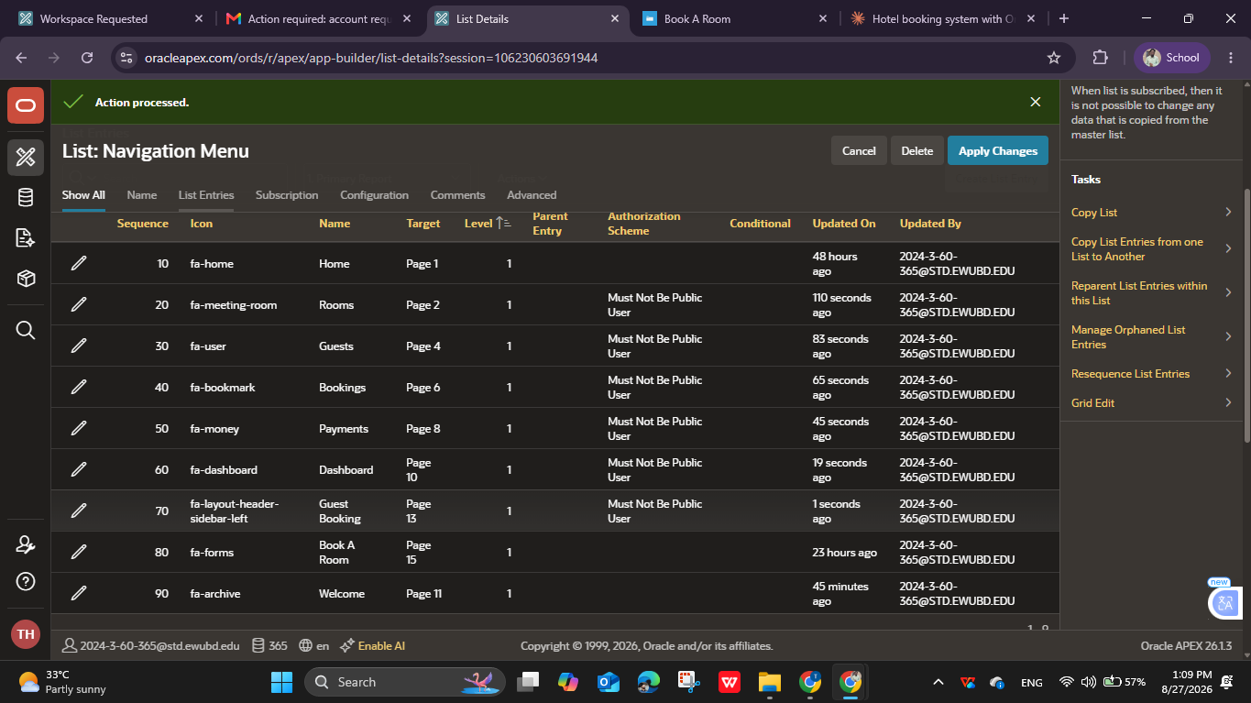

Figure: Navigation Menu configuration — "Must Not Be Public User" applied to every administrative entry

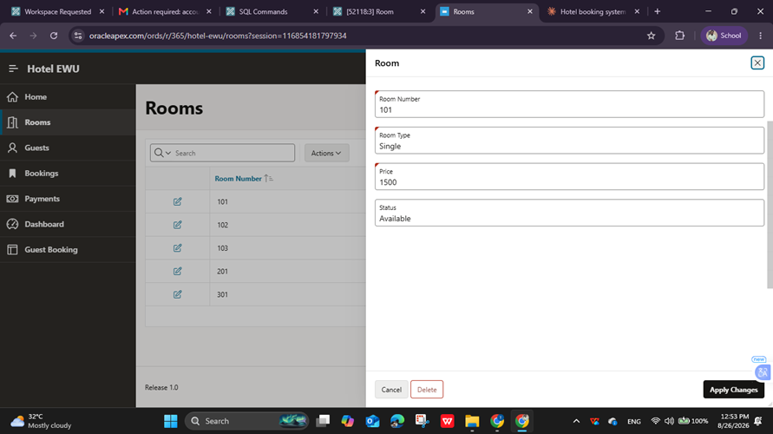

Figure: The Delete button on the Room form, itself protected by a page-level "Is Admin" authorization scheme
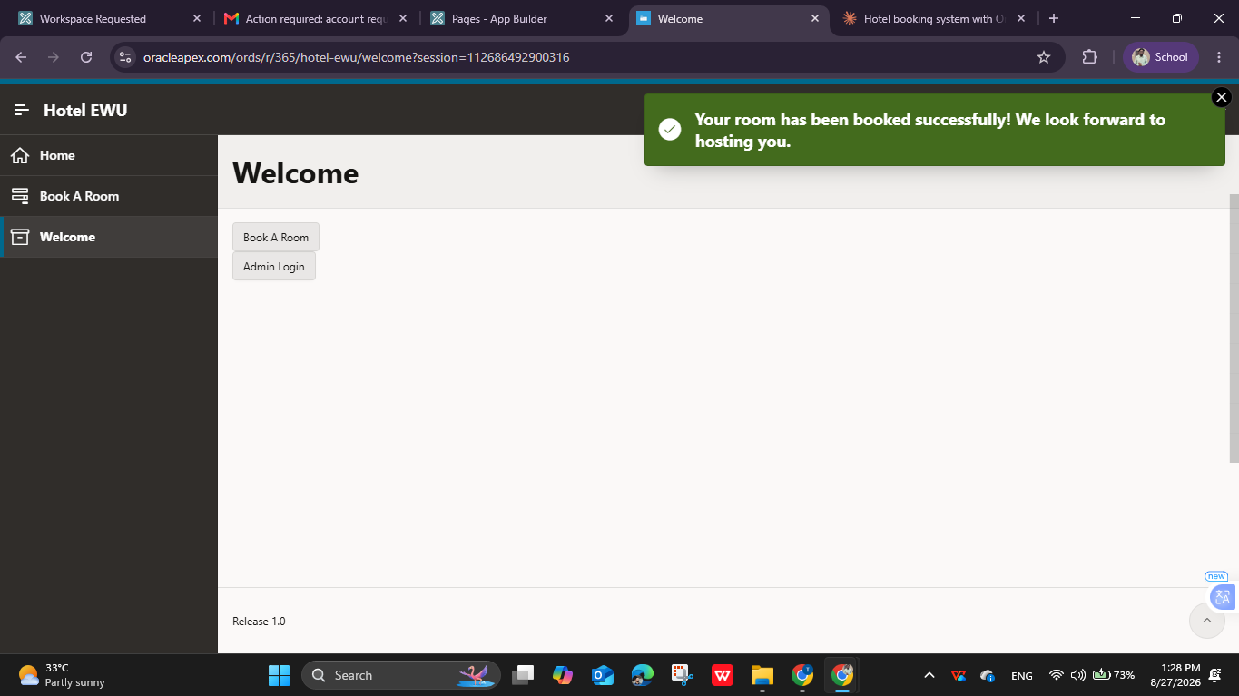

Figure : A customer completing a booking through the public page and receiving a confirmation message

12.Advanced feature:
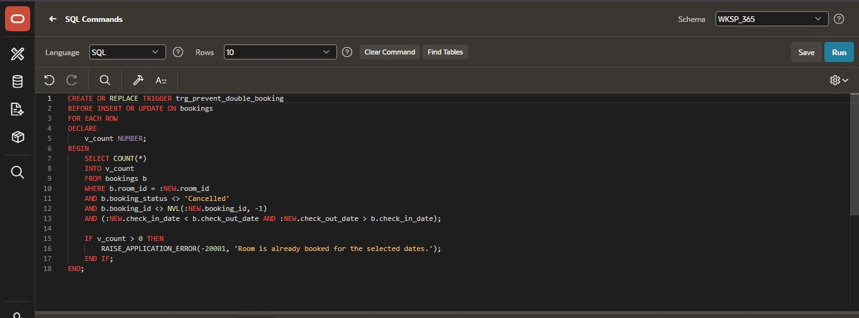
Figure:Trigger
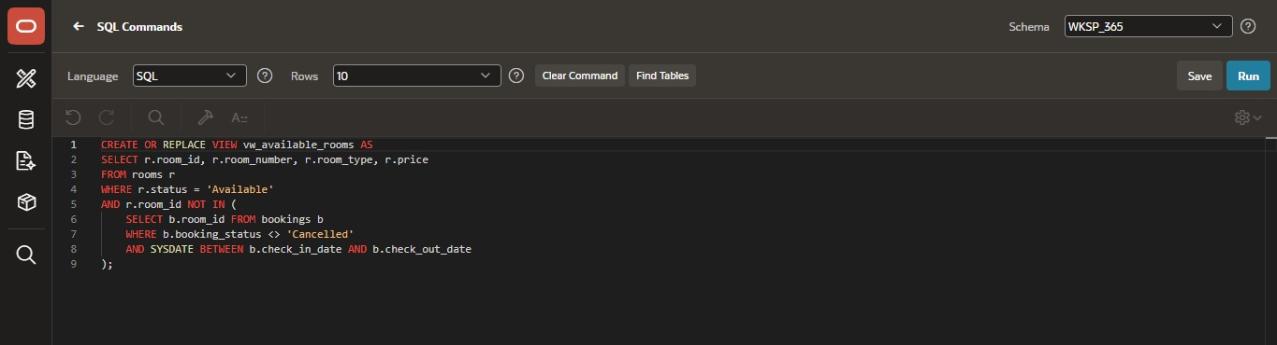
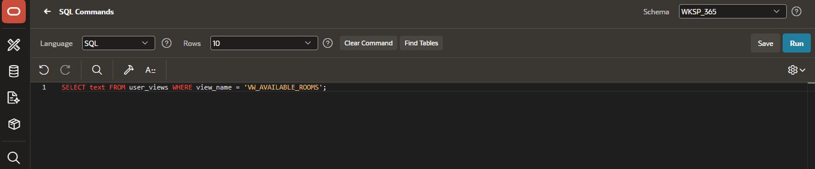
Figure:SQL Comands for create view

13. Concluding Remarks:

Building this project turned out to be a much deeper exercise than we expected going in. The database side — tables, constraints, the availability VIEW, the double-booking TRIGGER, and the stay-duration aggregate queries — came together fairly smoothly once we got comfortable with SQL Commands and IDENTITY-column gaps.
The real learning happened on the Oracle APEX side. We ran into and worked through: LOV types silently defaulting to a Shuttle instead of a Select List; PL/SQL page processes appearing to "disappear" from the Page Designer tree depending on their execution point; a case-sensitivity mismatch between :APP_USER and a stored username that made an authorization scheme fail silently; and a branch that redirected a public customer straight into a login wall after a successful booking. Each of these forced us to actually understand how APEX executes a page — in what order processes run, where authorization is evaluated, and how session state is cached — rather than just clicking through wizards.
The most satisfying part was reshaping the project from a purely administrative CRUD app into something that behaves like a real hotel booking system: a public, login-free page where an actual customer can check availability, book a room, and pay, with an admin-only backend kept completely separate and protected. Getting the demo to work end-to-end — from an anonymous visitor landing on the Welcome page to a completed, trigger-protected booking — was genuinely rewarding after a fairly long debugging journey. Thank you, and looking forward to the feedback.

